Faculty of Information Technology (FIT) – Ho Chi Minh City University of Science (HCMUS)
CS423 / CSC13003 – Software Testing (AI-augmented · 2026)
AI POLICY · TEMPLATES — 2026 v1.0

AI Use Disclosure Form
Attach to assignments where AI was used in any permitted capacity.
Adapted from Med Kharbach, PhD (2026) — AI Use Policy Templates for Higher Education. CC BY-NC-SA 4.0. This adaptation is prepared for FIT@HCMUS – CS423 / CSC15003 Software Testing course.

1. Course & Student Info
Field | Value
Course: | CS423 / CSC13003 – Software Testing
Assignment ID: | HW0
Assignment Title:
AI Use Category (1–5): | Category ____
Date:
Student name: | Ngô Thế Đạt
Student ID: | 23127340

2. Disclosure Questions

1. AI tool(s) used:
List every AI tool used for this assignment (e.g., AI Tool (e.g., ChatGPT, Claude, Gemini), ChatGPT, GitHub Copilot, Cursor, Gemini).

2. Stage(s) of the assignment where AI was used:
Tick all that apply: [ ] brainstorming [ ] outlining [ ] drafting [ ] feedback [ ] revision [ ] coding [ ] data analysis [ ] visual design [ ] other (specify).

3. Main prompts or tasks given to the AI:
Paste the 2–3 most impactful prompts verbatim. For the full transcript, attach Appendix A (prompt_log.md).

4. Specific parts of the work AI contributed to:
Be specific. Example: 'AI generated TC01–TC15 in Section 3.2; I rewrote TC04 and TC11; AI did NOT contribute to Sections 1, 2, 4, or the AI Critique.'

5. How I reviewed, revised, or verified the AI output:
Describe your verification method (ran the test, checked the spec, asked the TA, looked up RFC, cross-checked with the ISTQB syllabus, etc.).

6. Citation (if required by course style guide):
Software Testing uses the IEEE style. Example: Anthropic. (2026). AI Tool (e.g., ChatGPT, Claude, Gemini) [Large language model]. https://claude.ai

3. Statement of Honesty
By signing below, I confirm that the disclosure above is accurate and complete. I understand that undisclosed or false disclosure of AI use is treated as academic misconduct and may result in a 0 grade for the assignment and disciplinary referral.

Signature
Student name (printed): | Ngô Thế Đạt
Student ID: | 23127340
Class / Cohort: | 23KTPM3
Course: | CS423 / CSC13003 – Software Testing
Instructor: | Hồ Tuấn Thanh
Date:
Signature: | 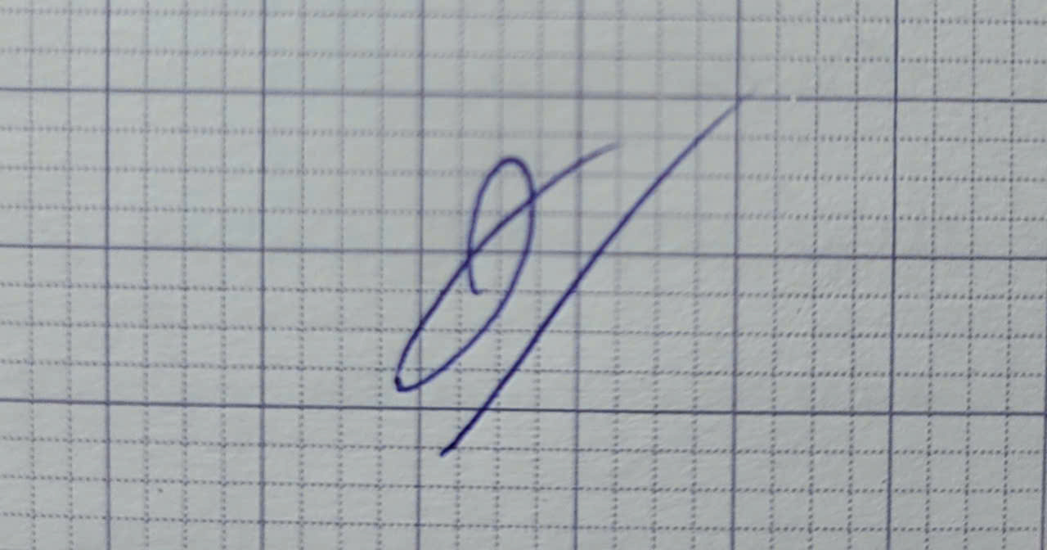

References
- Kharbach, M. (2026). AI Use Policy Templates for Higher Education. CC BY-NC-SA 4.0.
- ISTQB Foundation Level Syllabus (latest version).
- Hardman, P. (2025). A Post-AI Learning Taxonomy.
- Fuster Rabella, M. (2025). OECD Education Working Paper No. 338.
- Perkins, M., Roe, J., & Furze, L. (2025). AI Assessment Scale.
- Anthropic (2025). Building reliable AI test agents — engineering blog.
- DeepEval & Promptfoo documentation — testing frameworks for LLM systems.

